# CS 5633: Analysis of Algorithms

Homework 8

1. a)

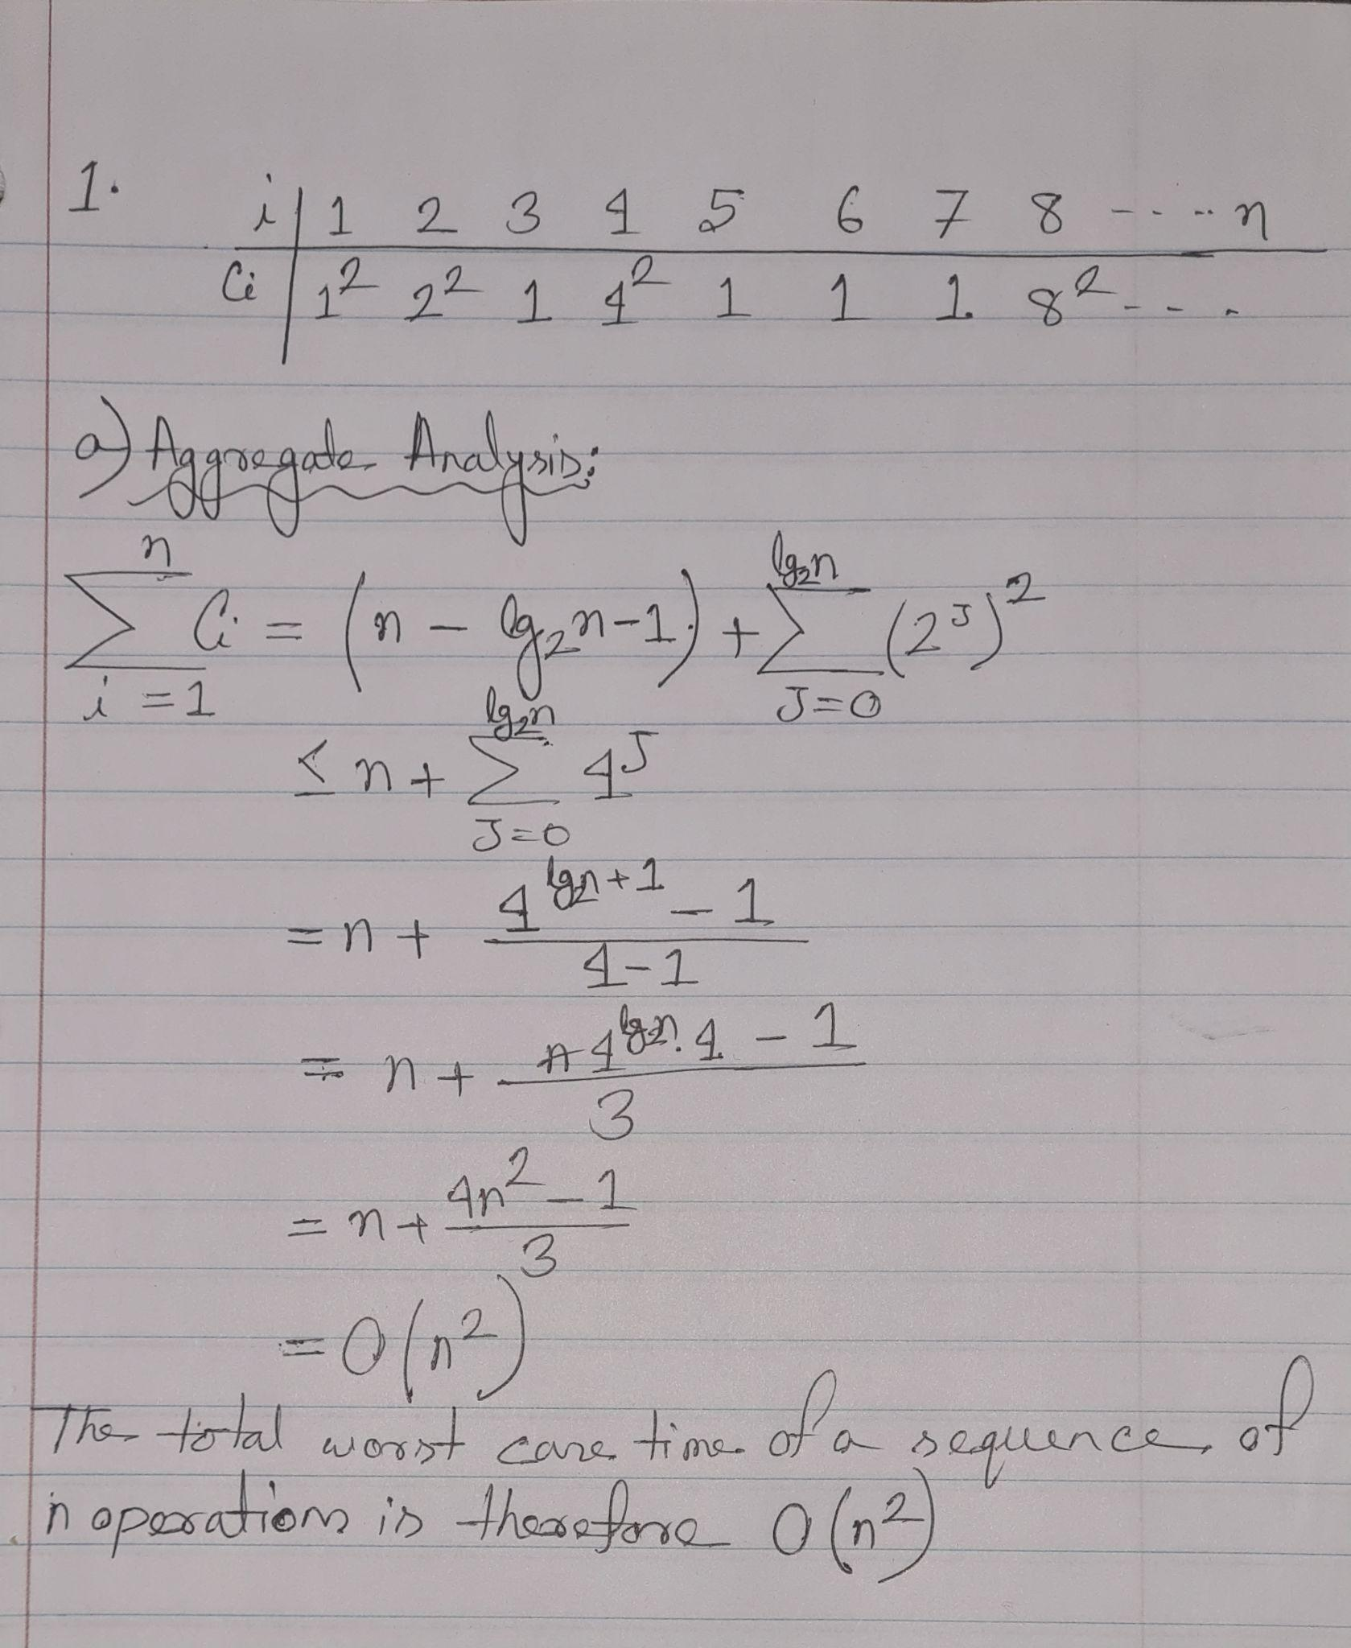

b) In the accounting method of amortized analysis, some operations charge(amortized cost) more, and some operations charge less than the actual cost.

Let us assume the amortized cost is $3 per operation and the actual cost is $4 where squaring is required and $1 where squaring is not required.

At every step of the operation, there will be some dollars left in the bank.

Ci  Cost

12 = 1 => $3 - $1 = $2

22 => $3 - $4 + $2 = $1

1 => $3 - $1 + $1 = $3

.

.

.

Thus, at each step, there are some dollars left in the bank. So, the amortized cost for a single operation is O(n).

2. Topological Sort:

1) a b d e c f

2) a b d c e f

3) a b c d e f

4) a d b e c f

5) a d b c e f

6) a d e b c f

3.

It is possible to use DFS to find a cycle in a graph. Only when a back edge is present in a graph can there be a cycle. We will preserve a visited array to discover the rear edge of any of its ancestors, and if there is a back edge to any visited node, then the cycle exists.

function cycle_exist(int v, bool visited[], int p) {

visited[v] = true

for (i = adjacent[v].start to end) {

if (!visited[i]) {

if (cycle_exist(i, visited, v)

return true

} else if(i != p) {

return true

}

}

return false

}

function modified_DFS() {

bool visited[V] = {0}

for (int i = 0 to V-1) {

if (!visited[i])

if (cycle_exist(i, visited, -1))

return true;

}

return false;

}

Here, the run time of this algorithm = O(n+m) where n is the number of vertices and m is the number of edges.